000000BINTEO – MANUAL TESTING REPORT
Multi-Device Functional, UI, Compatibility & Regression Testing
Application: Binteo
Testing Type: Manual Testing
Tester: P. Shanmathi
Platform: Android
Devices Tested: Vivo Y21e, Vivo Y200, Redmi Note 8 Pro

1. TESTING OBJECTIVE
The objective of this testing was to manually validate the Binteo application across multiple Android devices with different Android versions, RAM configurations and processor specifications.
The testing covered:
- User registration
- Login
- Google login
- Invalid credential validation
- Profile
- Dashboard
- Entertainment section
- Reels
- Video upload
- Video playback
- Watch Later
- Creator Showcase
- Channel creation
- Support Desk
- Token generation
- Marketplace
- Light and Dark mode
- Navigation
- Scrolling
- Cross-device UI consistency
- Basic regression testing
The main focus was to identify device-specific issues, UI inconsistencies, navigation problems, validation defects and content/video-related issues.

2. TEST ENVIRONMENT
Device 1 – Vivo Y21e
Model: V2140
Android Version: Android 12
RAM: 3 GB + 0.50 GB
Processor: 2.4 GHz
The application was tested on Vivo Y21e for authentication, navigation, entertainment, dashboard/profile and theme-related behaviour.

Device 2 – Vivo Y200
Model: Vivo Y200
Android Version: Android 15
RAM: 8 GB + 8 GB
Processor: 2.0 GHz
The application was tested on Vivo Y200 for Google login, account creation, valid login and UI/theme behaviour.

Device 3 – Redmi Note 8 Pro
Model: M1906G71
Android Version: Android 11
RAM: 6 GB
Processor: Octa-core, maximum 2.05 GHz
The application was tested extensively for authentication, profile, dashboard, Support Desk, channel creation, video, reels, marketplace and theme-related functionality.

3. AUTHENTICATION TESTING
3.1 Google Login
Normal Google login was tested on the available devices.
Observed Result:
Google login was working correctly in the tested flow.
Status: PASS

3.2 New Account Creation – Valid Credentials
A new account was created using a valid email address and password.
Observed Result:
The application accepted the valid credentials and account creation/login worked in the tested flow.
Status: PASS

3.3 Invalid Email Validation
On Redmi Note 8 Pro, account creation was tested using an invalid email address with a valid password.
Observed Result:
The application accepted the invalid email address instead of displaying an appropriate validation message.
Expected Result:
The application should validate the email format and display an appropriate error message for an invalid email address.
Status: FAIL
Defect ID: BIN-AUTH-001
Screenshot:
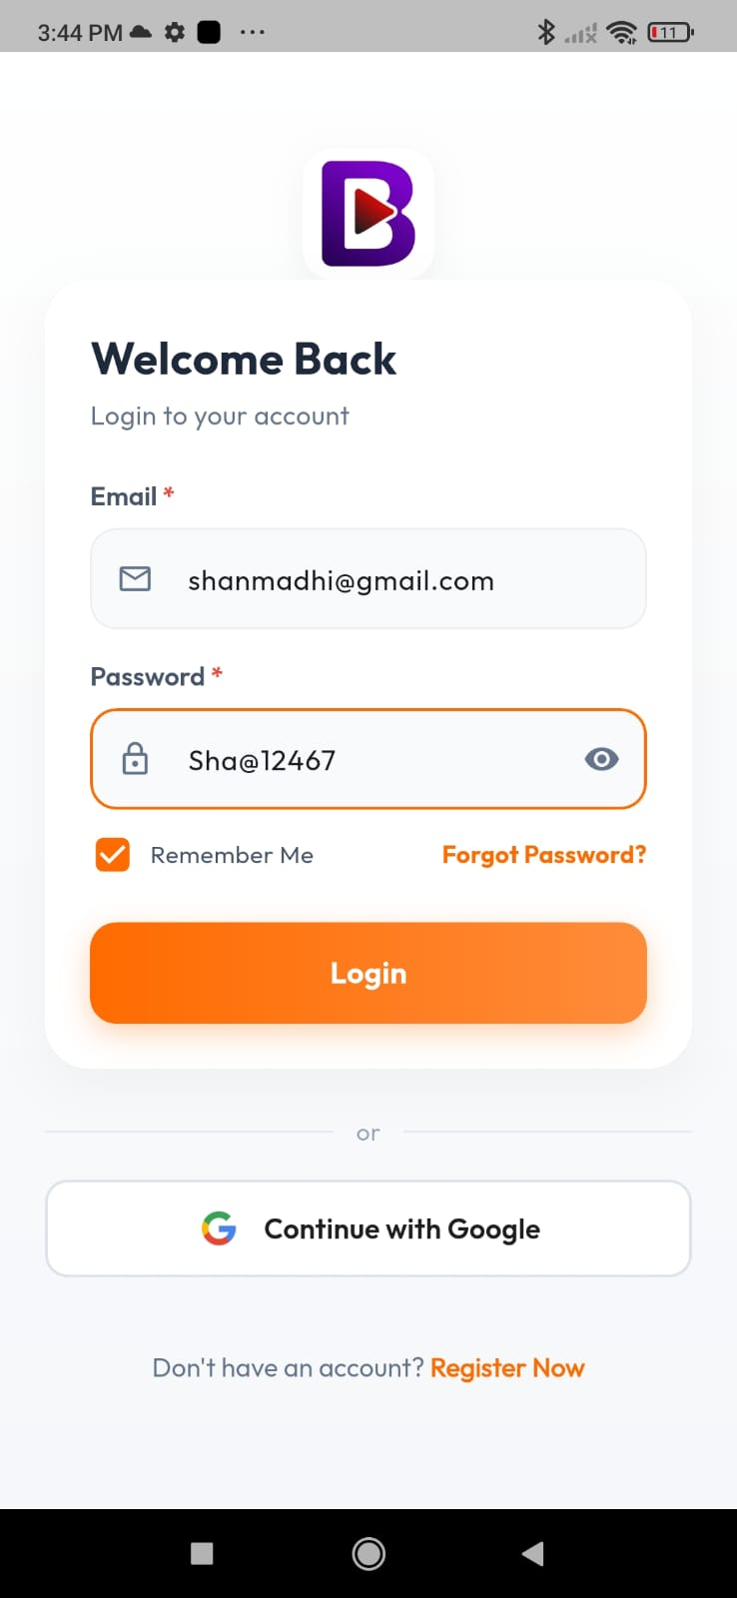

4. UI AND THEME TESTING
4.1 Location Bar Colour
On Vivo Y21e and Vivo Y200, the location bar was observed.
Observed Result:
The location bar appeared black on the outside and green on the inside. The same appearance was observed in both Light Mode and Dark Mode.
Observation:
The colour behaviour should be reviewed for consistency with the selected application/device theme.
Status: Observation
Screenshot:

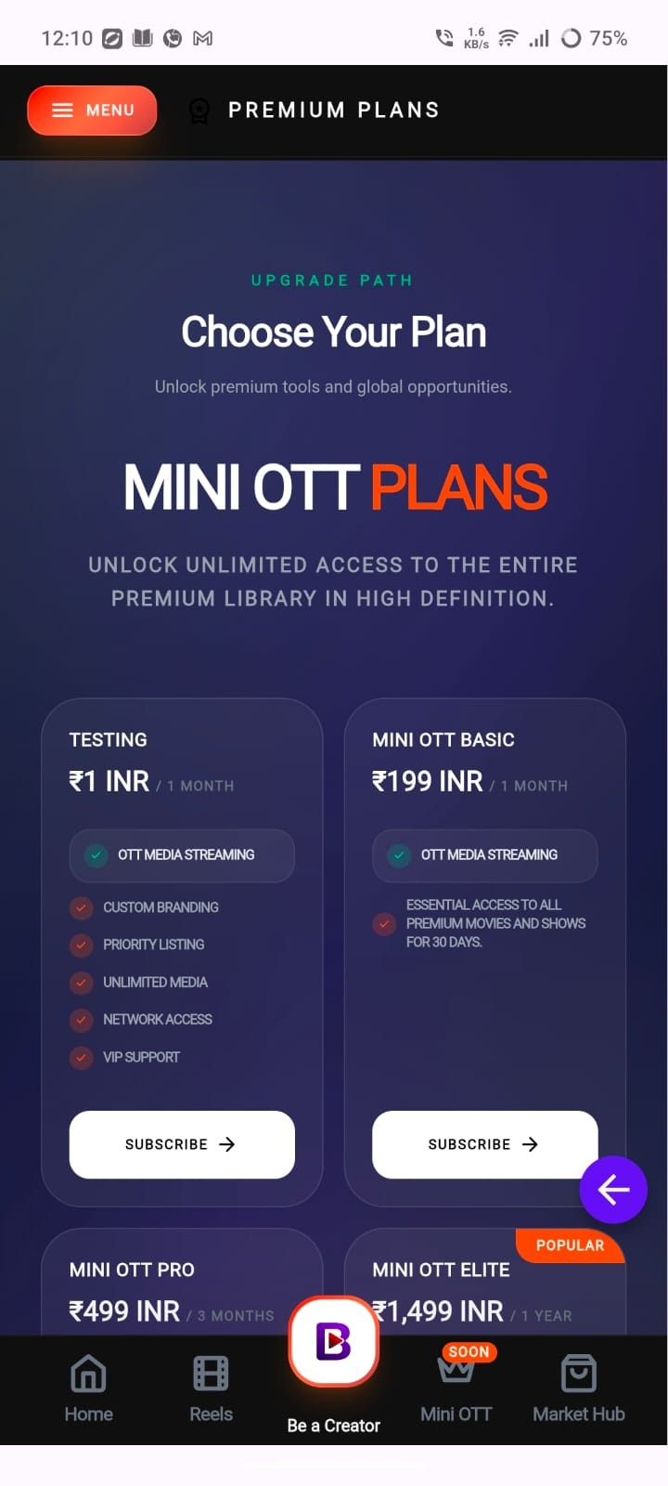

5. PROFILE TESTING
5.1 Profile Icon Visibility
On Redmi Note 8 Pro, the profile icon was checked.
Observed Result:
The profile icon was not visible.
Expected Result:
The profile icon should be clearly visible and accessible to the user.
Status: FAIL
Defect ID: BIN-PRO-001
Screenshot:
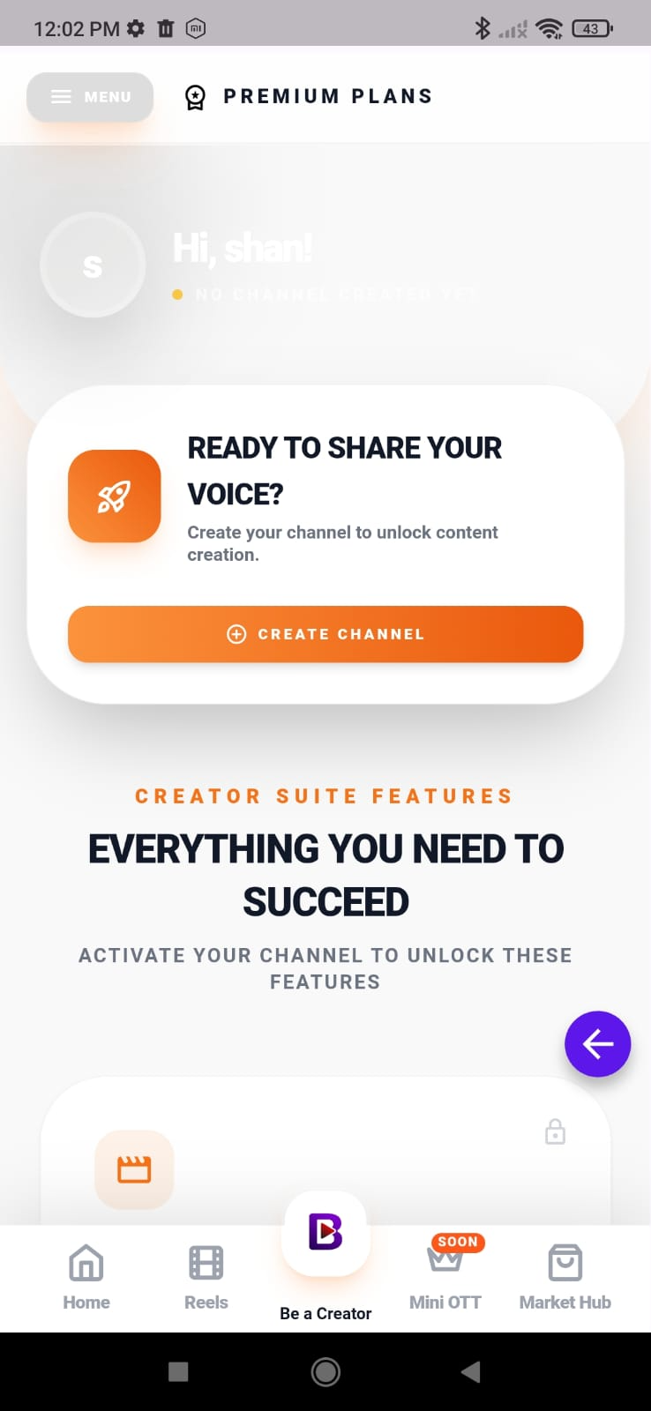
5.2 Featured Profile
The Featured Profile section was tested on Redmi Note 8 Pro.
Observed Result:
The Featured Profile appeared in grey colour.
Observation:
The colour presentation differs from the expected/other device appearance.
Status: Observation

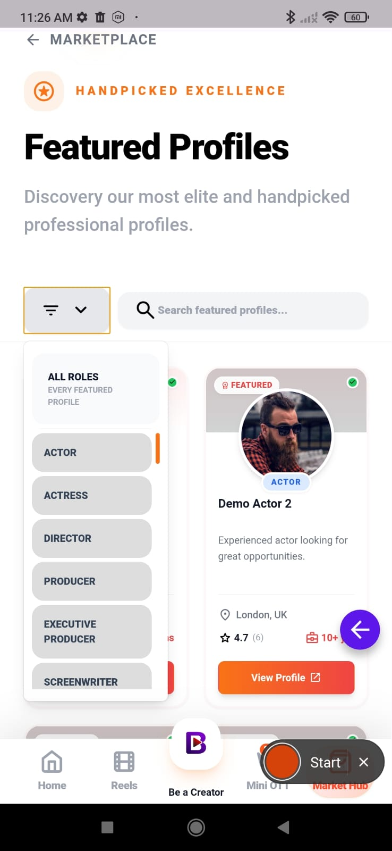

5.3 Creator Showcase
The Creator Showcase profile was tested.
Observed Result:
The Featured Profile in Creator Showcase was not fully displayed. An error/code appeared and the application automatically went back.
Expected Result:
The complete profile should be displayed without an unexpected error or automatic navigation.
Status: FAIL
Defect ID: BIN-CREATOR-001
Click the below link:
https://drive.google.com/file/d/10yjUxxiVWiv9yx3kDOgTO7D5mc_EqoNo/view?usp=sharing

6. DARK MODE AND LIGHT MODE TESTING
6.1 Dark Mode – Redmi Note 8 Pro
Dark Mode was tested on Redmi Note 8 Pro.
Observed Result:
Dark Mode was not working as expected.
Expected Result:
All applicable screens and components should change correctly according to the selected theme.
Status: FAIL
Defect ID: BIN-THEME-001
Click the link below
https://drive.google.com/file/d/1EJvHFSXOo5ofbPD__4Z0MAVY2kM-3bZw/view?usp=sharing

6.2 Saved Audio Theme Issue – Vivo Y21e
The Saved Audio section was checked under Dashboard/Profile.
Observed Result:
When the device was in Dark Mode, Saved Audio appeared with a white-mode appearance.
Expected Result:
Saved Audio should follow the selected Dark Mode theme.
Status: FAIL
Defect ID: BIN-THEME-002
Screenshot:

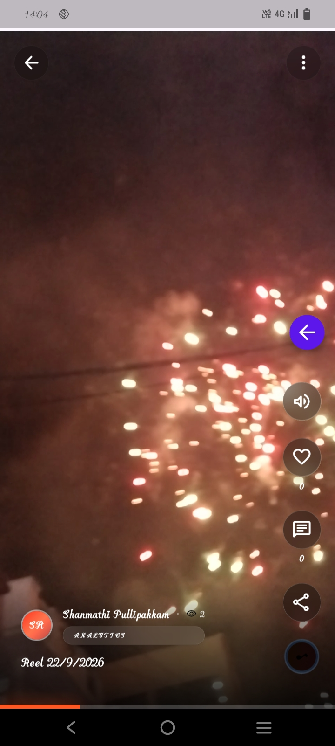

6.3 Icon Visibility in Dark Mode
On Redmi Note 8 Pro, icons were checked in Light Mode and Dark Mode.
Observed Result:
The icon was visible in Light Mode but was not visible in Dark Mode.
Expected Result:
Icons should remain visible and usable in both themes.
Status: FAIL
Screenshot:

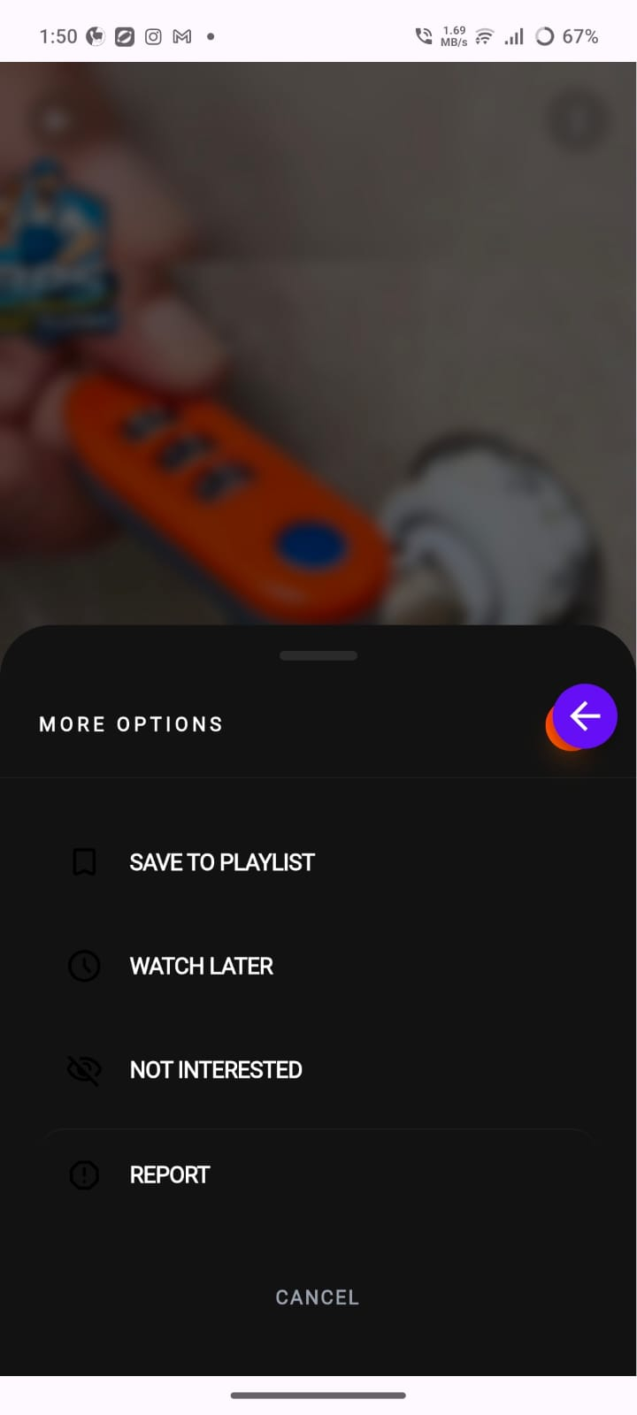

7. NAVIGATION TESTING
7.1 Back Button – Vivo Y21e
The application navigation was tested using the Back button.
Observed Result:
Sometimes the Back button was not responding.
Expected Result:
The Back button should consistently perform the expected navigation action.
Status: FAIL
Defect ID: BIN-NAV-004
Click the below link:
https://drive.google.com/file/d/1CrE7WzQ4lI84sa0qWIKxZQtUJpPfP7U8/view?usp=sharing
7.2 Entertainment Section Scrolling – Vivo Y21e
Scrolling behaviour was tested in the Entertainment section.
Observed Result:
Scrolling was not working completely. The section did not consistently move to another section while scrolling. In some cases, tapping first caused the section to move.
Expected Result:
The Entertainment section should respond smoothly to normal touch scrolling.
Status: FAIL
Defect ID: BIN-SCROLL-001
Click the below link:
https://drive.google.com/file/d/1hHoj4co1hF7Rk1mokZOLYTV9Fy4FjvYS/view?usp=sharing

8. DASHBOARD AND PROFILE TESTING
8.1 Dashboard/Profile Content
The Dashboard and Profile sections were checked.
Observed Result:
Profile-related content was observed under the Dashboard/Profile section.
The behaviour and presentation varied between devices.
Status: Observation

8.2 Profile Customisation and Analytics
After exiting and reopening the application, the Profile section was checked.
Observed Result:
- Customise section appeared in black.
- Videos section appeared in black.
- Analytics section appeared in white.
- The appearance was inconsistent between sections.
Expected Result:
All profile components should follow a consistent theme.
Status: FAIL / UI Observation
Screenshot:
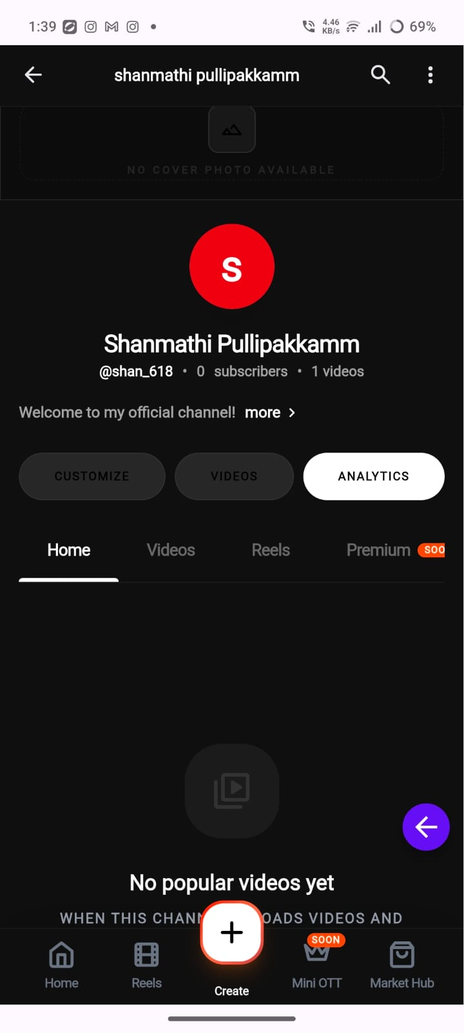

8.3 Profile Video
The uploaded video was checked from the user's profile.
Observed Result:
The video was visible in the profile area. However, when the Videos subsection was opened, the video was not displayed there.
Expected Result:
Uploaded videos should be consistently displayed in the appropriate Videos subsection.
Status: FAIL
Screenshot:
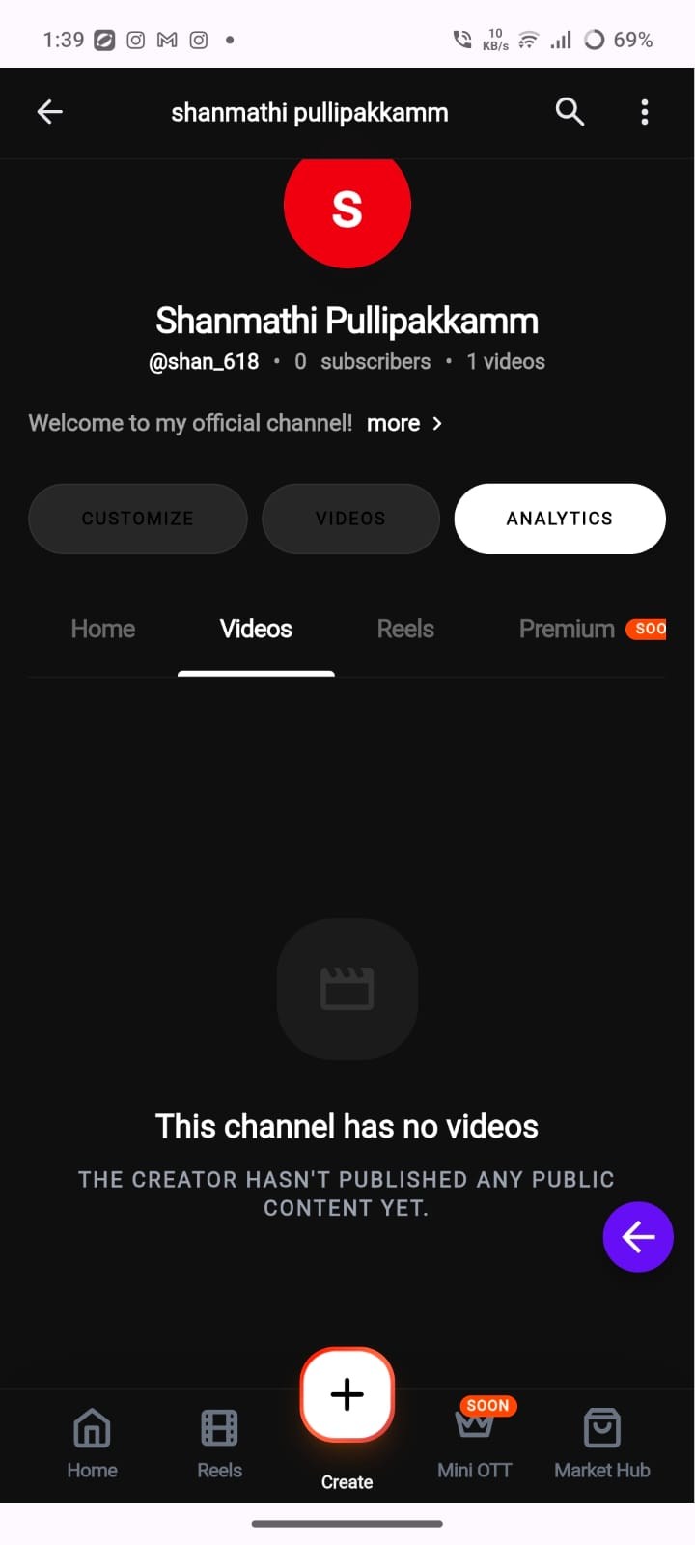

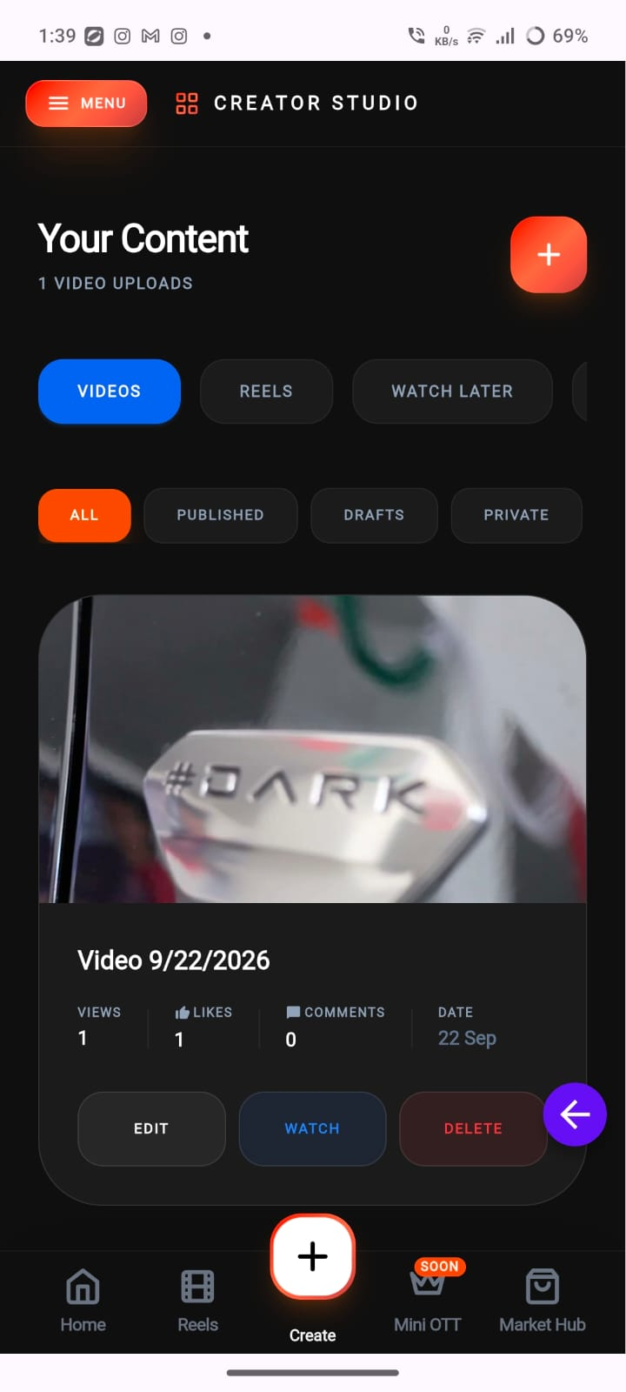

9. SUPPORT DESK TESTING
9.1 Support Desk Buttons
Support Desk was tested on Redmi Note 8 Pro.
Observed Result:
Support Desk buttons were not visible.
Expected Result:
All Support Desk buttons should be visible and accessible.
Status: FAIL
Defect ID: BIN-SUPPORT-001
Screenshot:
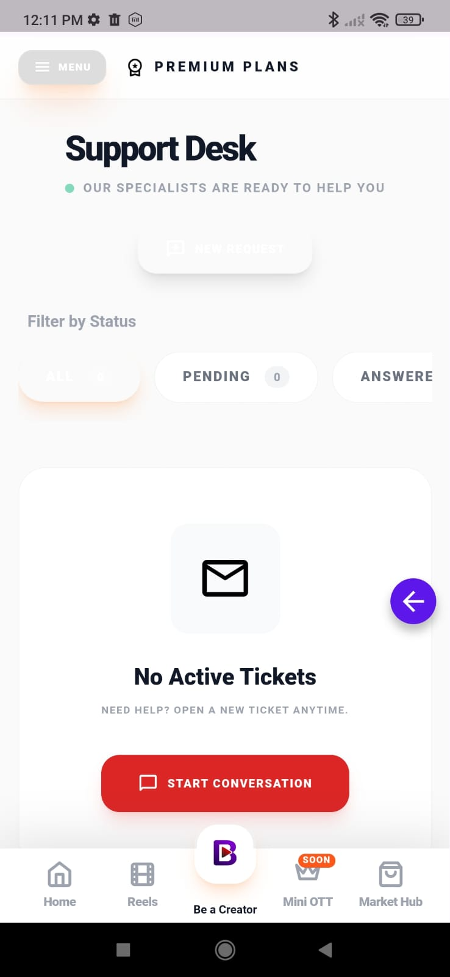9.2 Token Generation
A token/request was generated from the Support Desk.
Observed Result:
The request was accepted, but the expected successful popup/message was not displayed.
Expected Result:
After successful token generation, a clear success confirmation should be displayed.
Status: FAIL
Defect ID: BIN-SUPPORT-002
Screenshot:
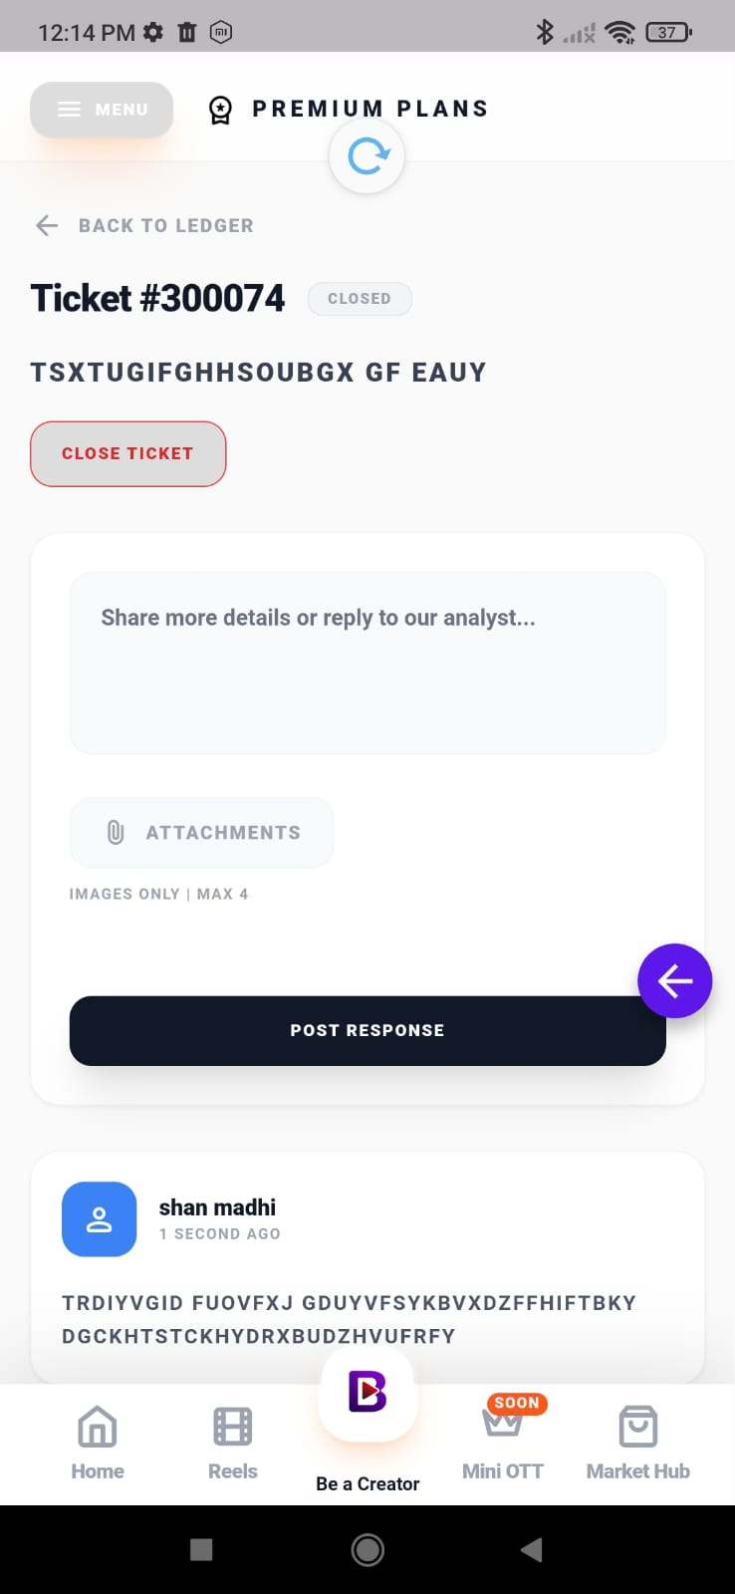

9.3 Support Desk Navigation
Support Desk navigation was tested across devices.
Observed Result:
The destination was inconsistent.
In different flows/devices, clicking Support Desk redirected to:
- Transaction page
- Home page
- OTT Plan page
Expected Result:
Support Desk should always navigate to the correct Support Desk destination.
Status: FAIL
Click the below link:
https://drive.google.com/file/d/12L2fl3LDgTXt0kwODQUvMvqpXJsx86mC/view?usp=sharing
10. CHANNEL CREATION TESTING
10.1 Username Validation
Channel creation was tested.
Observed Result:
Username was accepted correctly in the tested flow.
Status: PASS

10.2 Mobile Number Validation
The mobile number field was tested with more than 10 digits.
Observed Result:
The application accepted more than 10 digits.
Expected Result:
The mobile number field should restrict the user to the expected 10-digit mobile number format.
Status: FAIL
Defect ID: BIN-CHAN-001
Screenshot:
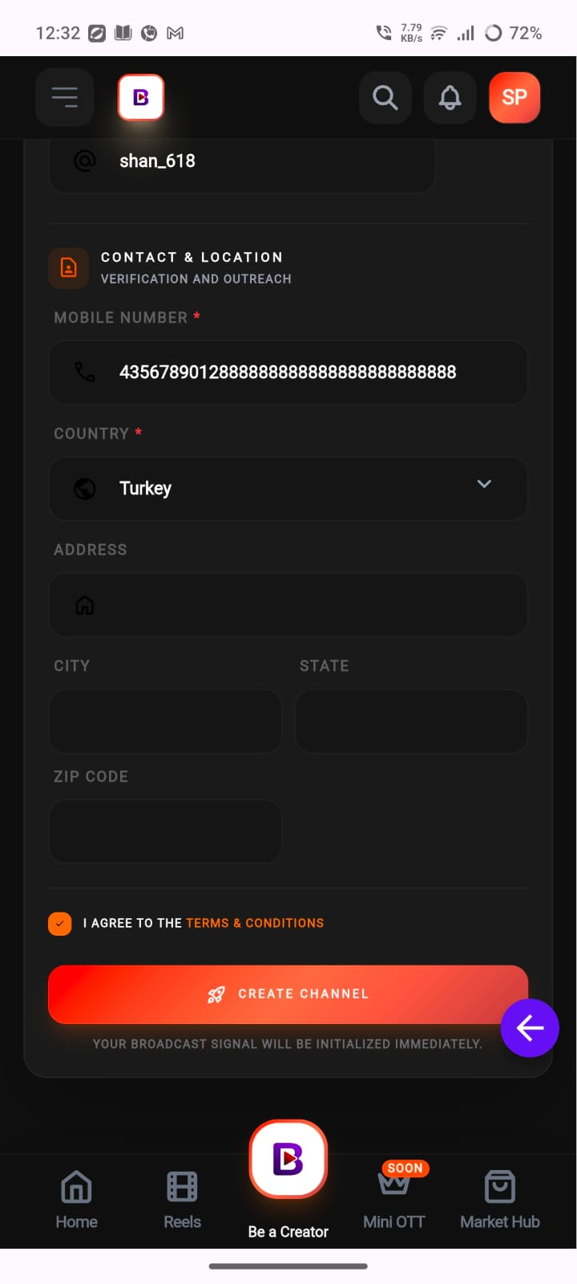

11. VIDEO UPLOAD AND HIDE FUNCTIONALITY
11.1 Hide Video from Homepage
A video was uploaded and the option to hide it from the homepage was selected.
Observed Result:
The hide option worked and displayed a successful message.
However, the video was still visible in the Chat Feed immediately after the action.
Expected Result:
Once the hide action is successfully completed, the video should immediately be removed from the applicable feed.
Status: FAIL / Delayed Update
Defect ID: BIN-VIDEO-001
Click the below link:
https://drive.google.com/file/d/1krKzn4o9nR4RZLjTOEkyvex9FTz1Im_H/view?usp=sharing

11.2 Video After Reopening Application
After exiting and reopening the application, the Chat Feed was checked again.
Observed Result:
The previously hidden video was no longer present in the Chat Feed.
Observation:
The hide operation appears to take effect after application reload/reopen rather than immediately.

12. PLAYLIST VIDEO PLAYBACK
The Dashboard Playlist section was tested.
Observed Result:
The playlist displayed the image/thumbnail of the video.
When the user clicked the playlist item, the video did not start playing.
Expected Result:
Clicking the playlist item should open and play the corresponding video.
Status: FAIL
Defect ID: BIN-VIDEO-002

Click the below link:
Https://drive.google.com/file/d/1MJRyT96pUhAcTage5UlddmEINGYMpKmU/view?usp=sharing

13. REELS TESTING
13.1 Reel Page Visibility
Reels were tested on Redmi Note 8 Pro.
Observed Result:
The Reel page was not visible in the tested flow, although audio was still playing.
Expected Result:
The Reel page and corresponding video content should be visible whenever reel audio is playing.
Status: FAIL
Screenshot:

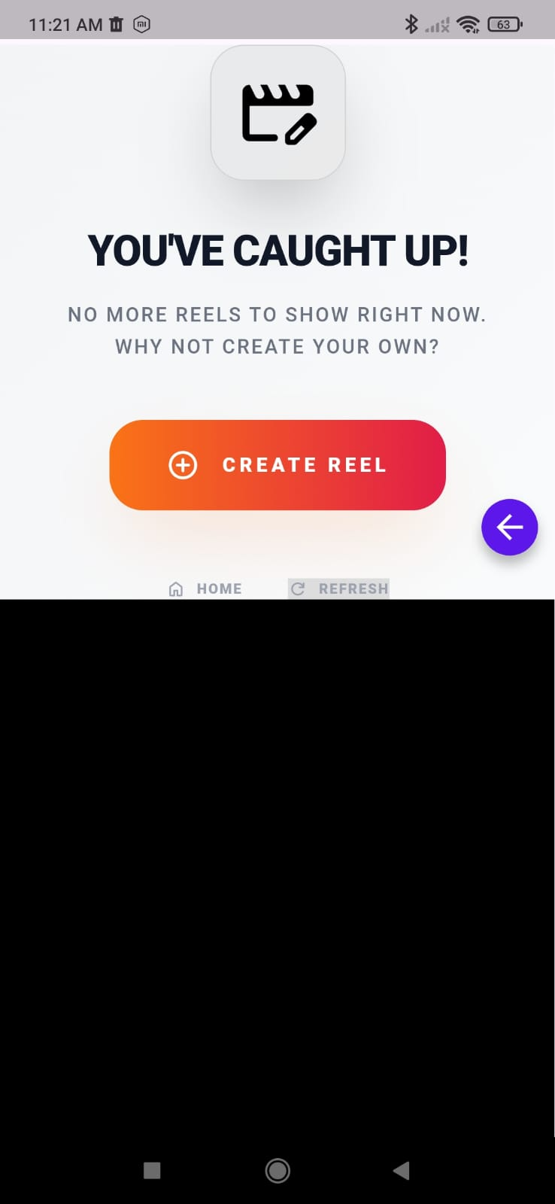

13.2 Watch Later
A reel was saved to Watch Later.
The saved reel was then opened again.
Observed Result:
An error message was displayed when returning to the saved reel.
Expected Result:
A saved reel should open and play successfully from Watch Later.
Status: FAIL
Defect ID: BIN-REEL-001
Click the below link:
https://drive.google.com/file/d/1OC6sJedeNVokcq-JkGFdwE4xC3KdDLW0/view?usp=sharing

13.3 Reel More Options
The three-dots icon on the Reels page was tested.
Observed Result:
The More Options tab opened correctly.
In Dark Mode, the icons were displayed.
In Light Mode, the icons were also enabled/visible in the tested flow.
Status: PASS / Observation

13.4 Reel Audio Button
Reel audio controls were tested.
Observed Result:
Some reels displayed the audio button while other reels did not.
Some reels were also stuck and did not behave consistently.
Expected Result:
The audio control should be consistently available wherever applicable, and reels should load/play without becoming stuck.
Status: FAIL
Defect ID: BIN-REEL-002
Screenshot:

13.5 Uploaded Reel Playback
A reel uploaded approximately two minutes earlier and older reels were checked.
Observed Result:
Some reels displayed the audio button, while some did not. Some reels became stuck.
Expected Result:
Recently uploaded and older reels should load and play consistently.
Status: FAIL
Defect ID: BIN-REEL-003
Click the below link:
https://drive.google.com/file/d/13ryaflbW9_I1ylfv2tGEMvZDQjQZQK2F/view?usp=sharing

13.6 Video Button – Down Control
The down-type control in the video button was tested.
Observed Result:
The control was not working.
Expected Result:
The down control should respond correctly when selected.
Status: FAIL
Defect ID: BIN-REEL-004
Click the below link:
https://drive.google.com/file/d/1v3Oekbehxh2ujiC7_zzg0jGRC8J4Dy0h/view?usp=sharing

14. MARKETPLACE TESTING
14.1 Featured Marketplace
Marketplace was tested on Redmi Note 8 Pro.
Observed Result:
In the Featured section, the Previous button was not visible.
Expected Result:
The Previous button should be displayed whenever there are previous items/pages available.
Status: FAIL
Defect ID: BIN-MKT-001
Click the below link:
https://drive.google.com/file/d/1QspjQd9Ug30BG4zqb2LEpV20agpaGKaQ/view?usp=sharing

15. TRENDING SECTION
The Trending section was checked.
Observed Result:
Trending content appeared inside a gold-colour box.
Observation:
The colour presentation should be verified against the approved UI design and compared across devices.
Status: Observation

16. CROSS-DEVICE UI OBSERVATION
The application was tested on three different Android devices:
- Vivo Y21e – Android 12
- Vivo Y200 – Android 15
- Redmi Note 8 Pro – Android 11
The UI colour and theme presentation varied between the three devices.
The differences were especially noticeable in:
- Profile section
- Dashboard
- Saved Audio
- Icons
- Dark Mode
- Creator Showcase
- Video sections
- Support Desk
This indicates that additional cross-device UI consistency testing should be performed after defect fixes.

17. CONSOLIDATED DEFECTS IDENTIFIED
The following major defects/issues were identified during the testing cycle:
BIN-AUTH-001
Invalid email is accepted during account creation on Redmi Note 8 Pro.
BIN-PRO-001
Profile icon is not visible on Redmi Note 8 Pro.
BIN-THEME-001
Dark Mode is not working as expected on Redmi Note 8 Pro.
BIN-THEME-002
Saved Audio displays white-mode styling when the device is in Dark Mode on Vivo Y21e.
BIN-NAV-004
Back button sometimes does not respond on Vivo Y21e.
BIN-SCROLL-001
Entertainment section scrolling is inconsistent on Vivo Y21e.
BIN-SUPPORT-001
Support Desk buttons are not visible on Redmi Note 8 Pro.
BIN-SUPPORT-002
Successful token-generation popup is not displayed.
BIN-SUPPORT-003
Support Desk redirects inconsistently to Transaction, Home or OTT Plan.
BIN-CHAN-001
Mobile number field accepts more than 10 digits.
BIN-VIDEO-001
Hidden video remains temporarily visible in the Chat Feed until the application is reopened.
BIN-VIDEO-002
Playlist video thumbnail is displayed, but the video does not play when selected.
BIN-REEL-001
Saved Watch Later reel produces an error when reopened.
BIN-REEL-002
Reel audio button is inconsistently visible.
BIN-REEL-003
Some reels become stuck during playback/loading.
BIN-REEL-004
Down-type control in the video button is not working.
BIN-MKT-001
Previous button is not visible in the Marketplace Featured section.
BIN-CREATOR-001
Creator Showcase Featured Profile is not fully displayed and may show an error/code before automatically navigating back.

18. FUNCTIONALITY WORKING IN TESTED FLOWS
The following functionality was observed to work correctly in the tested scenarios:
- Normal Google login
- Valid account creation
- Valid email and password login
- Username handling during channel creation
- Hide-video action accepts the request
- Successful message is displayed after the hide-video action
- More Options tab on Reels opens when the three-dots icon is selected
- Several other application sections were functioning correctly during the tested flows
These results represent the specific flows tested and should not be interpreted as complete application-wide validation.

19. TESTING SUMMARY
Manual testing was performed on Binteo using three Android devices with different Android versions and hardware configurations.
The testing covered authentication, profile, dashboard, entertainment, reels, marketplace, creator features, Support Desk, channel creation, video upload, video playback, navigation and theme compatibility.
The application successfully completed several basic user flows, including Google login, valid account creation and valid login.
However, several issues were identified, particularly in:
- Input validation
- Dark/Light Mode
- Cross-device UI consistency
- Navigation
- Scrolling
- Support Desk
- Channel mobile-number validation
- Profile presentation
- Creator Showcase
- Video playback
- Playlist playback
- Reels
- Marketplace controls
Several of the observed issues were device-specific, while some behaviours were inconsistent across devices.

20. RECOMMENDATIONS FOR RETESTING
After the identified defects are fixed, the following areas should be retested:
- Invalid email validation.
- Mobile number length validation.
- Dark Mode across all screens.
- Light Mode and Dark Mode icon visibility.
- Profile icon visibility.
- Saved Audio theme.
- Back-button navigation.
- Entertainment scrolling.
- Support Desk button visibility.
- Token-generation success message.
- Support Desk navigation.
- Creator Showcase profile loading.
- Video hide functionality and immediate feed update.
- Playlist video playback.
- Watch Later reel playback.
- Reel audio button.
- Reel loading and playback.
- Video down-control.
- Marketplace Previous button.
- Overall cross-device UI consistency.

21. SCREENSHOT ATTACHMENT SECTION
The following screenshots can be added to the final report as evidence.
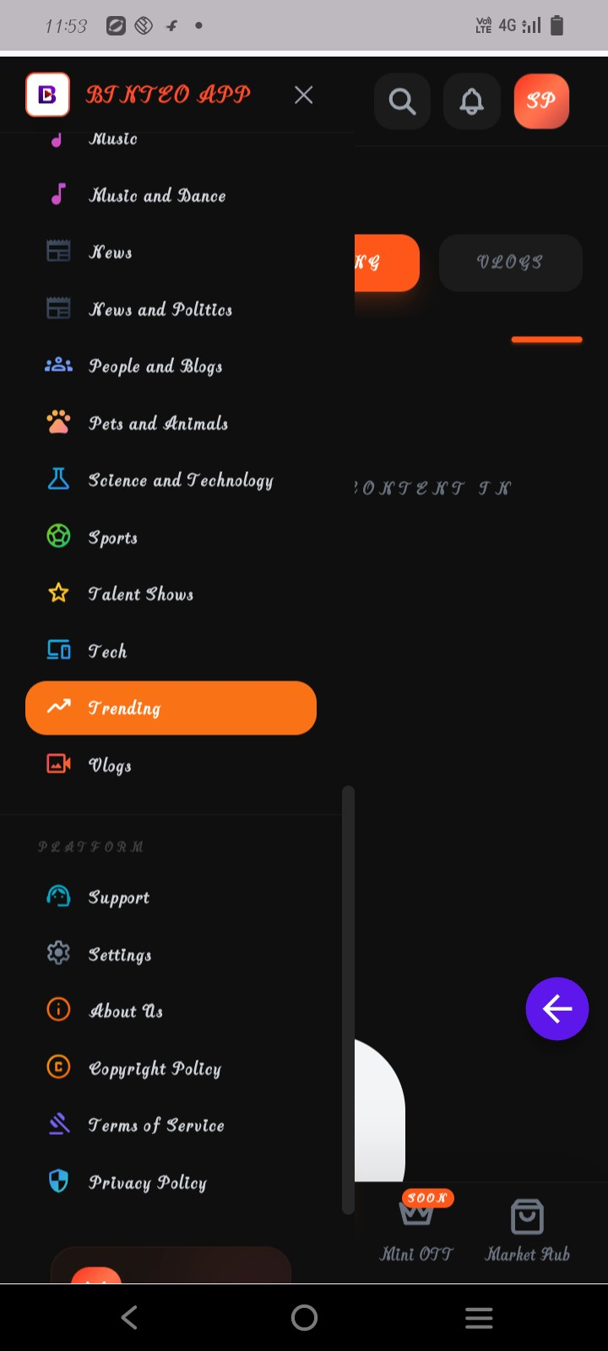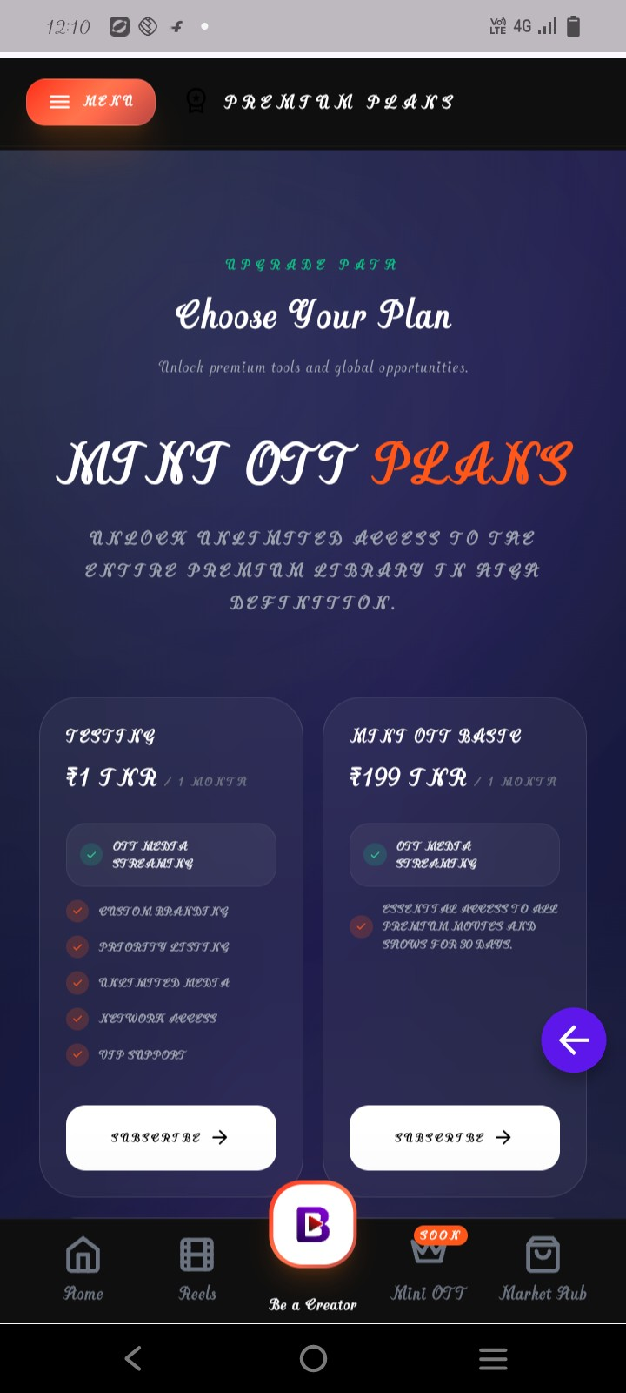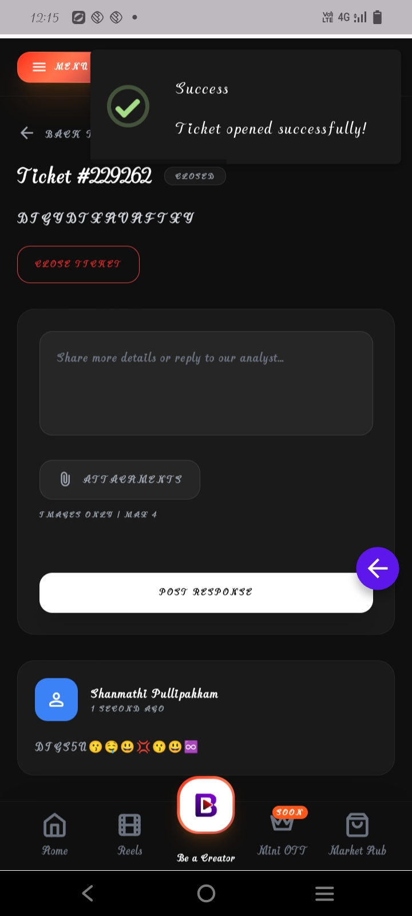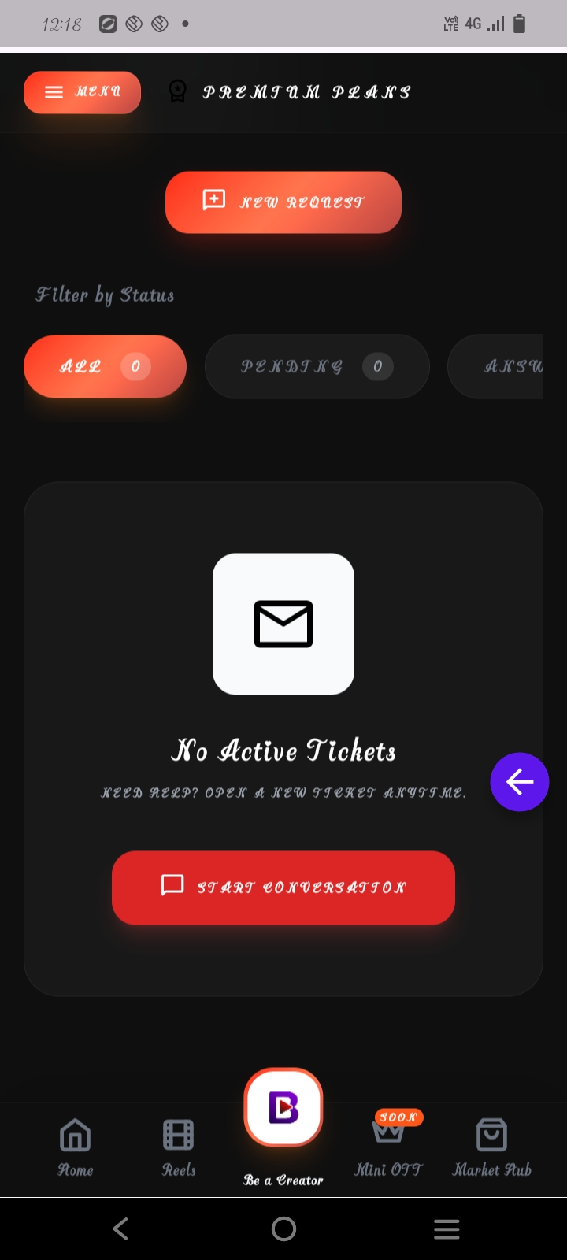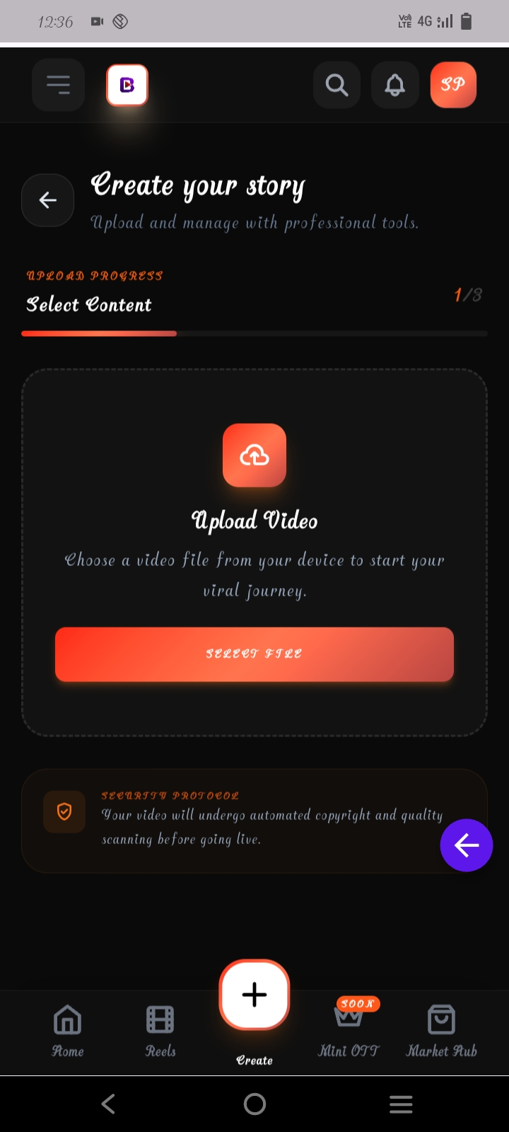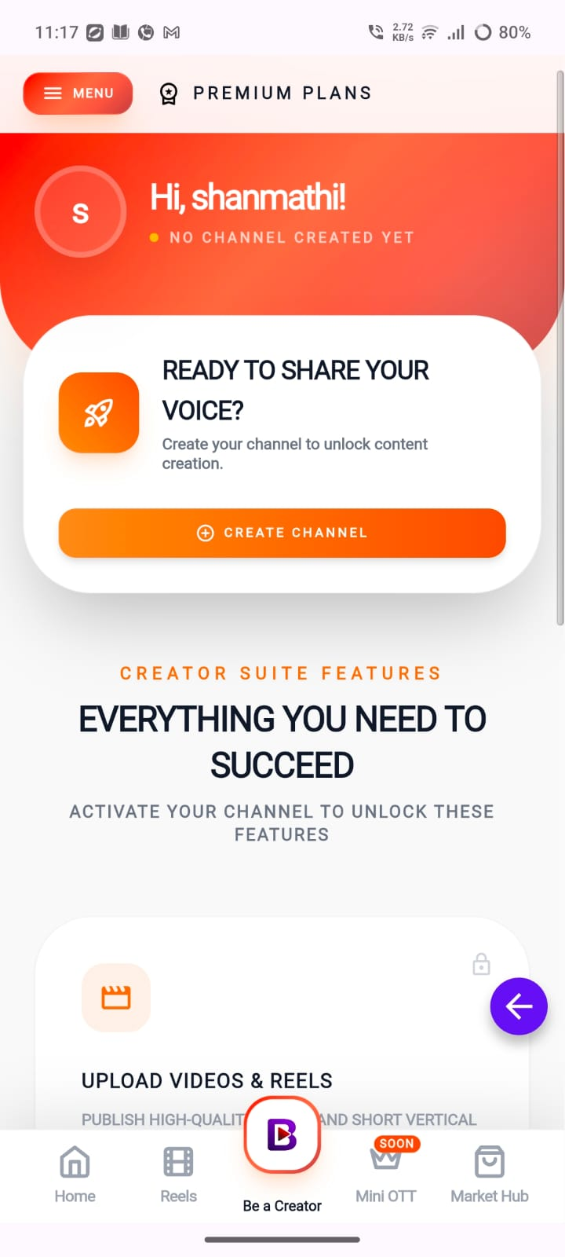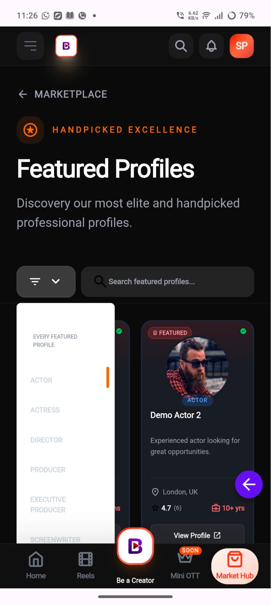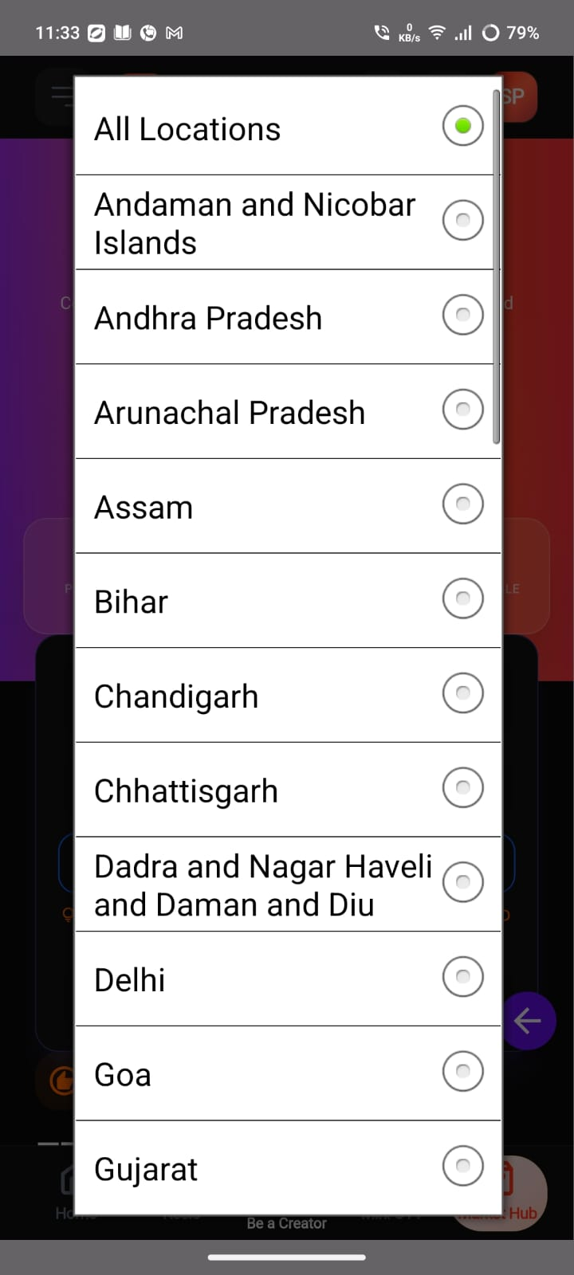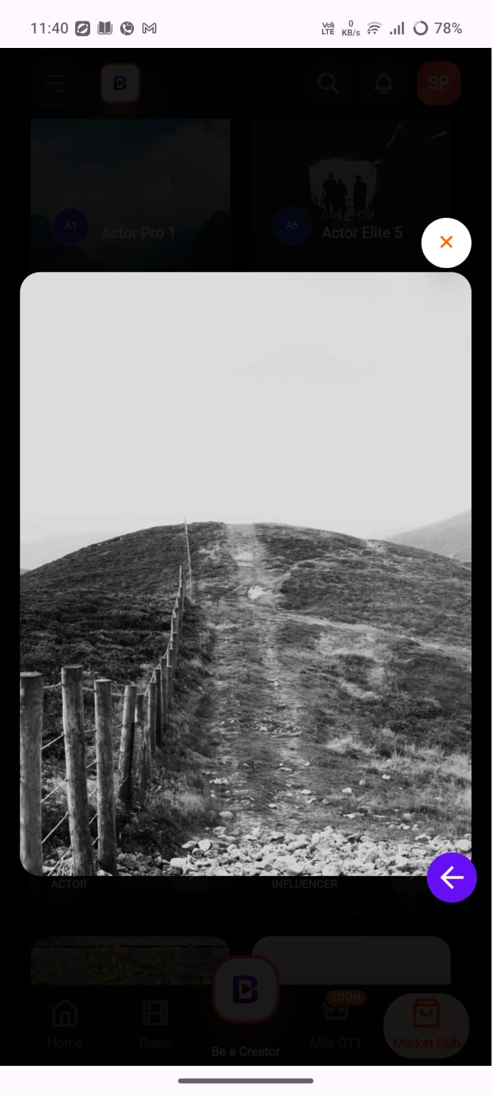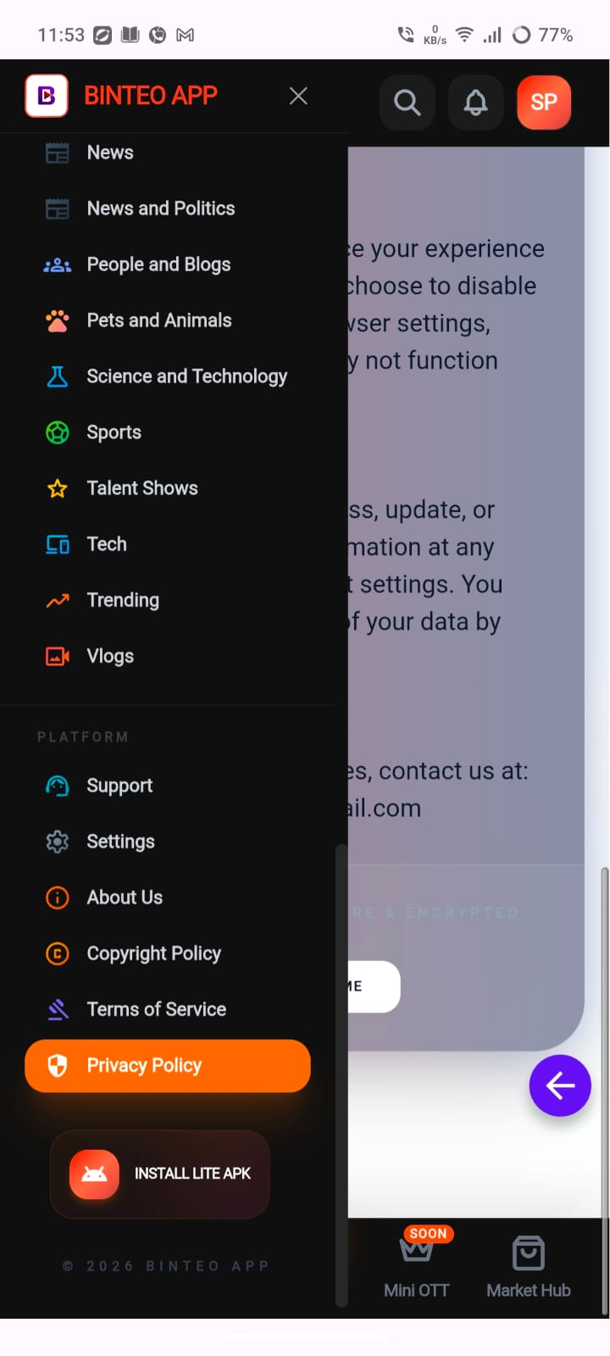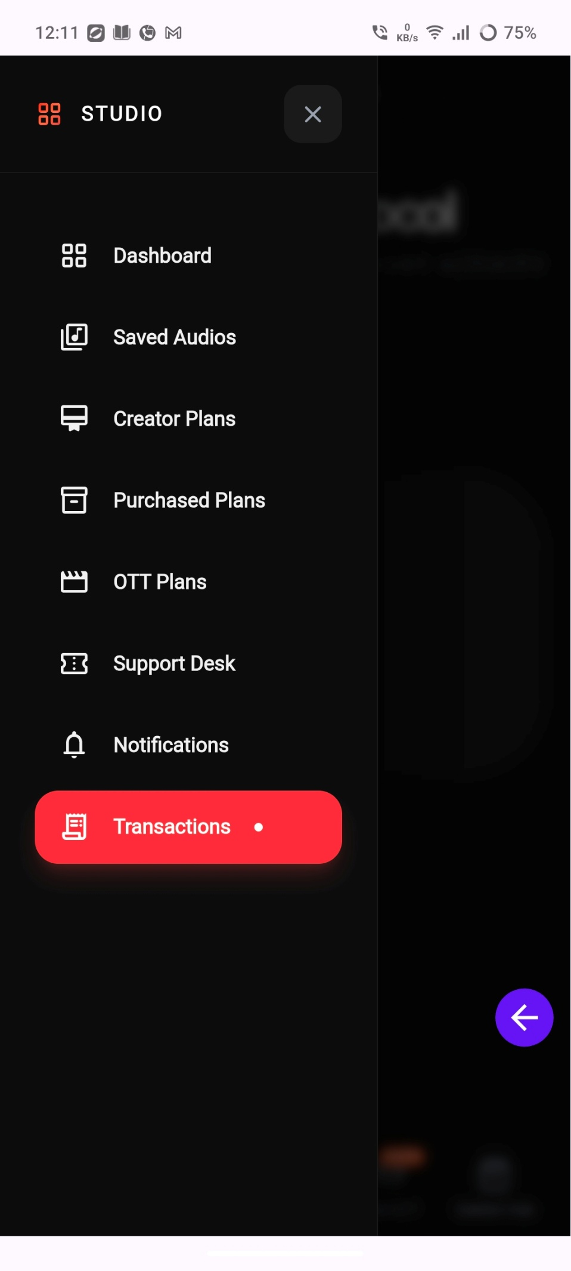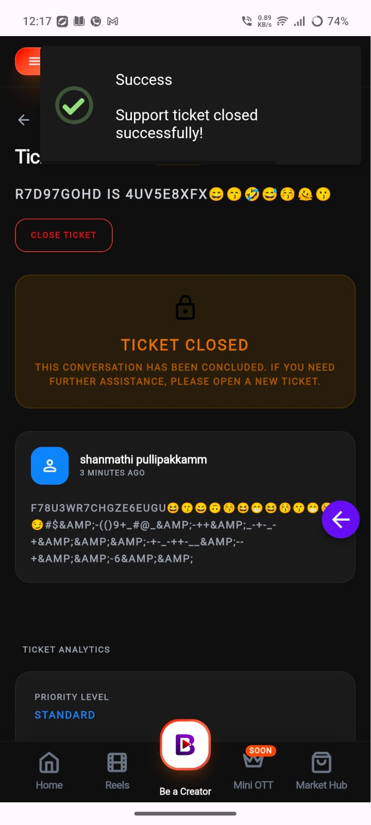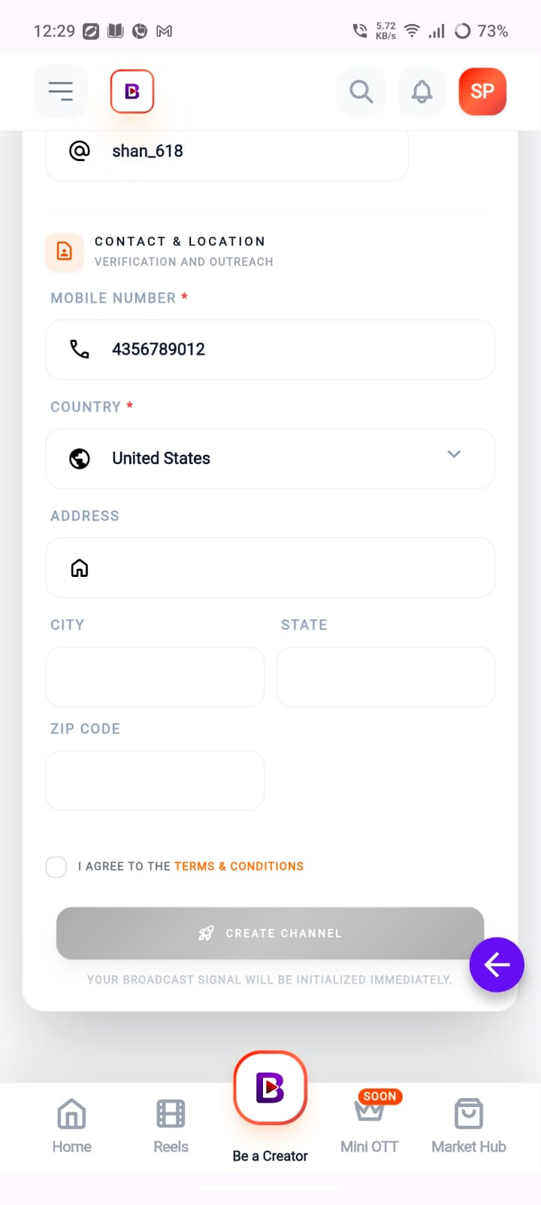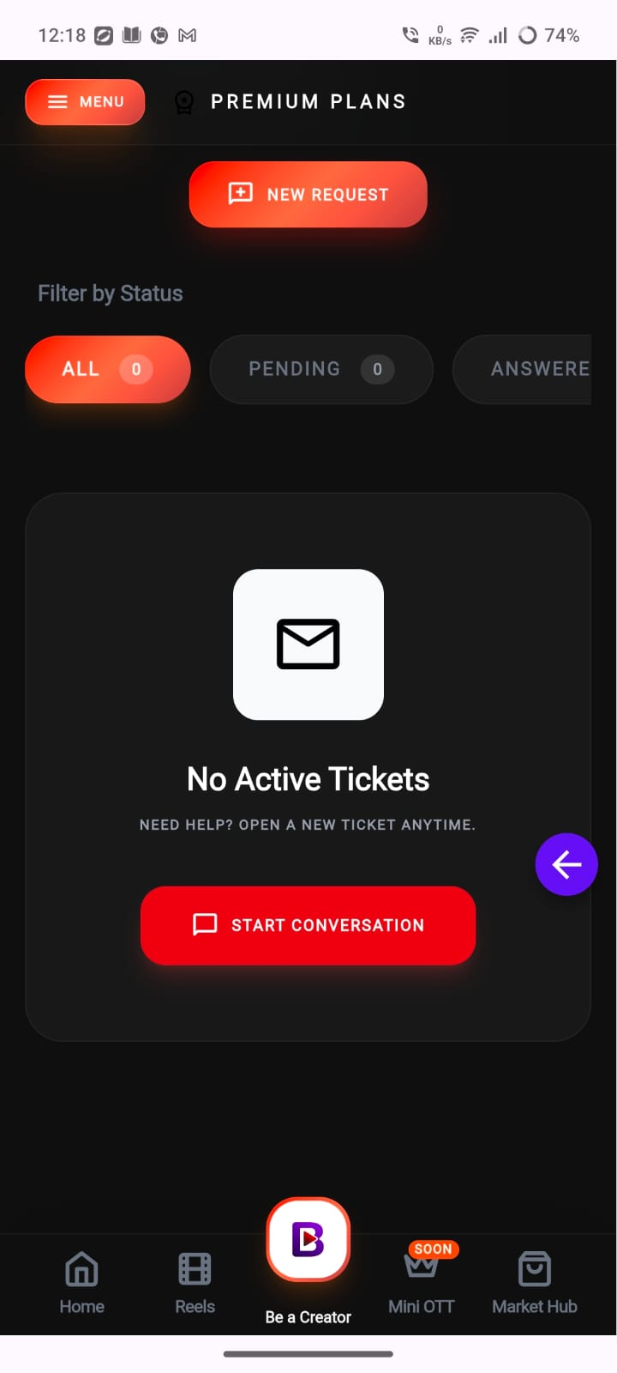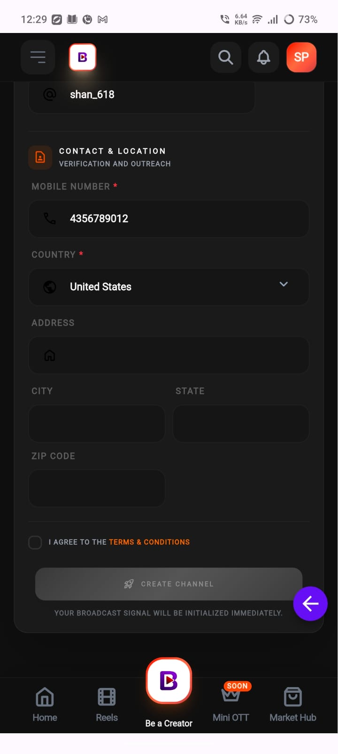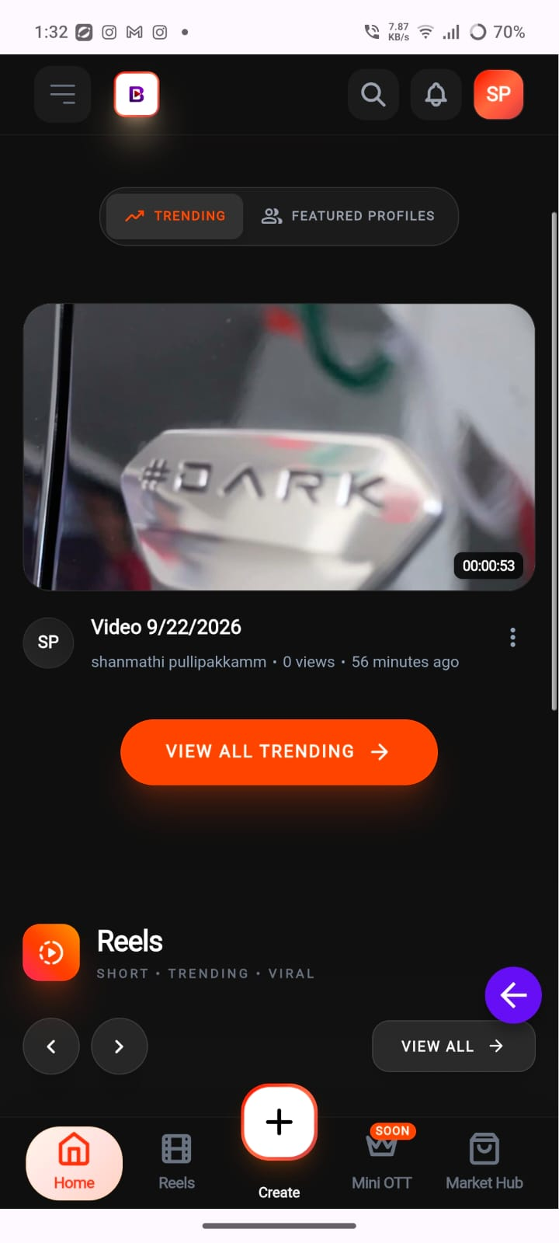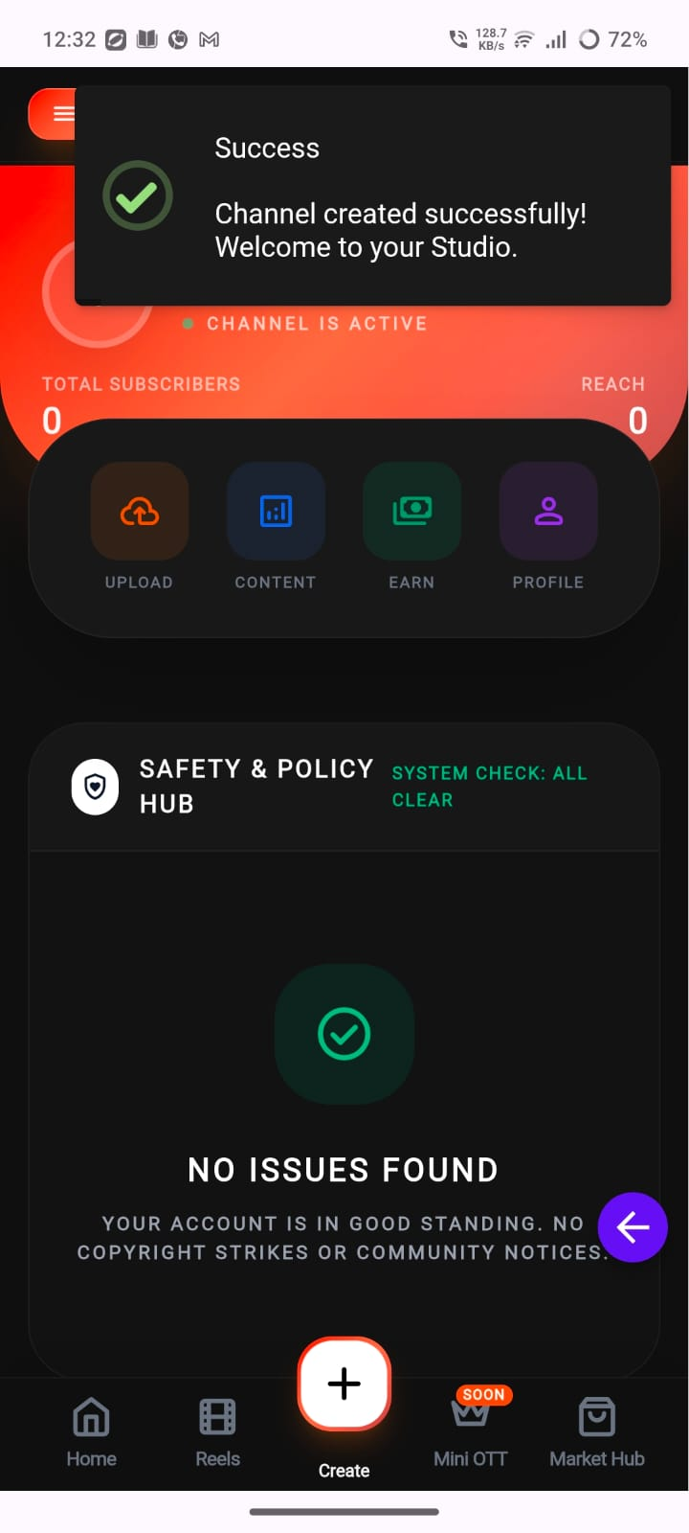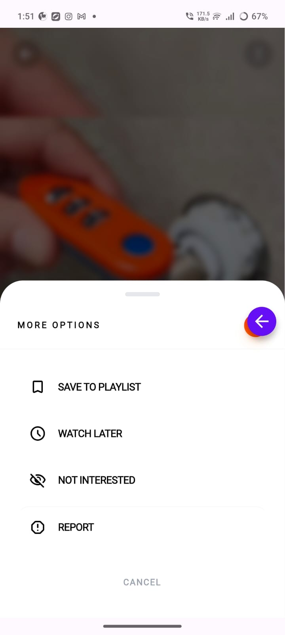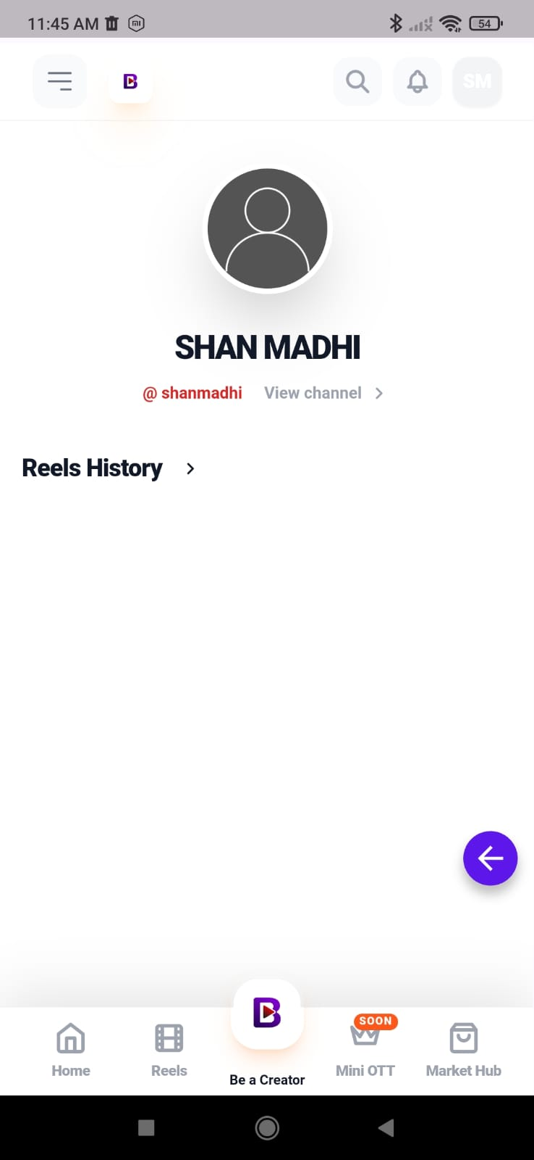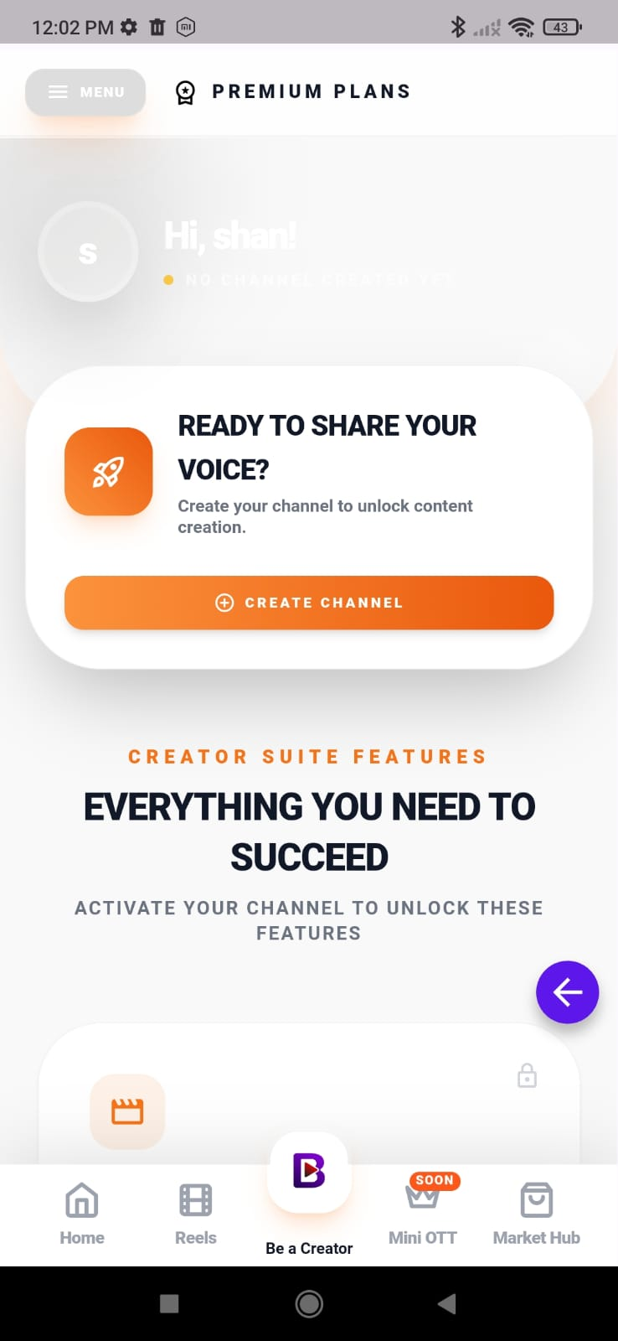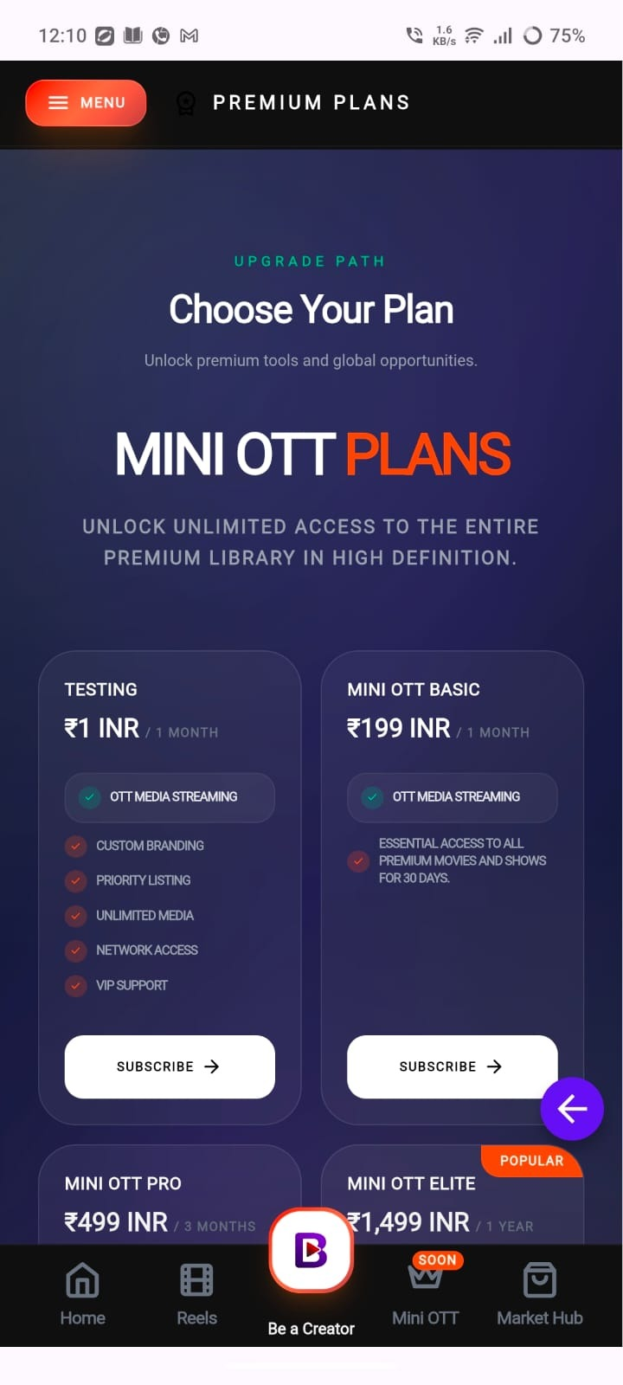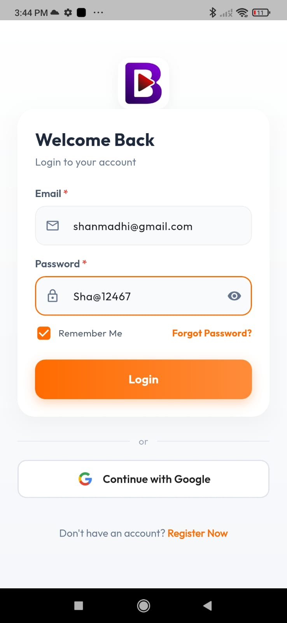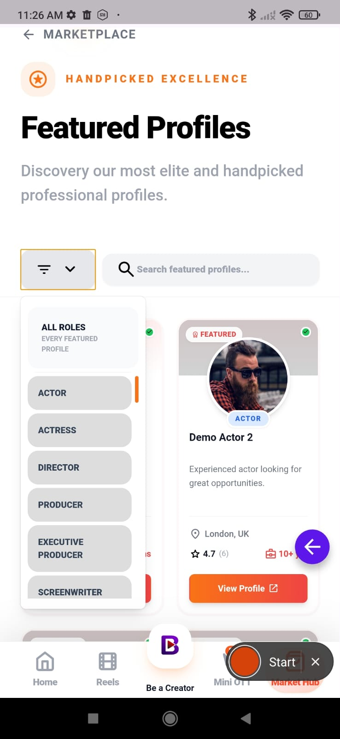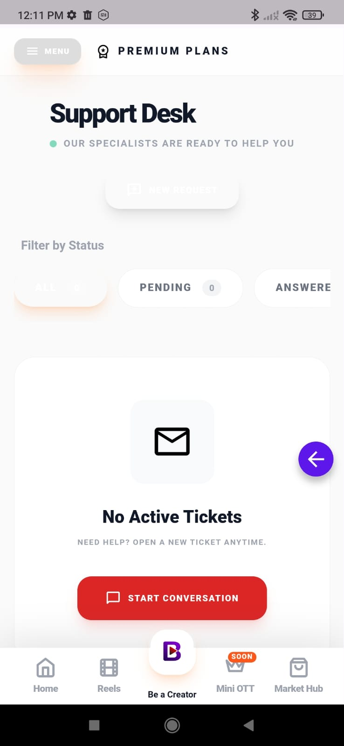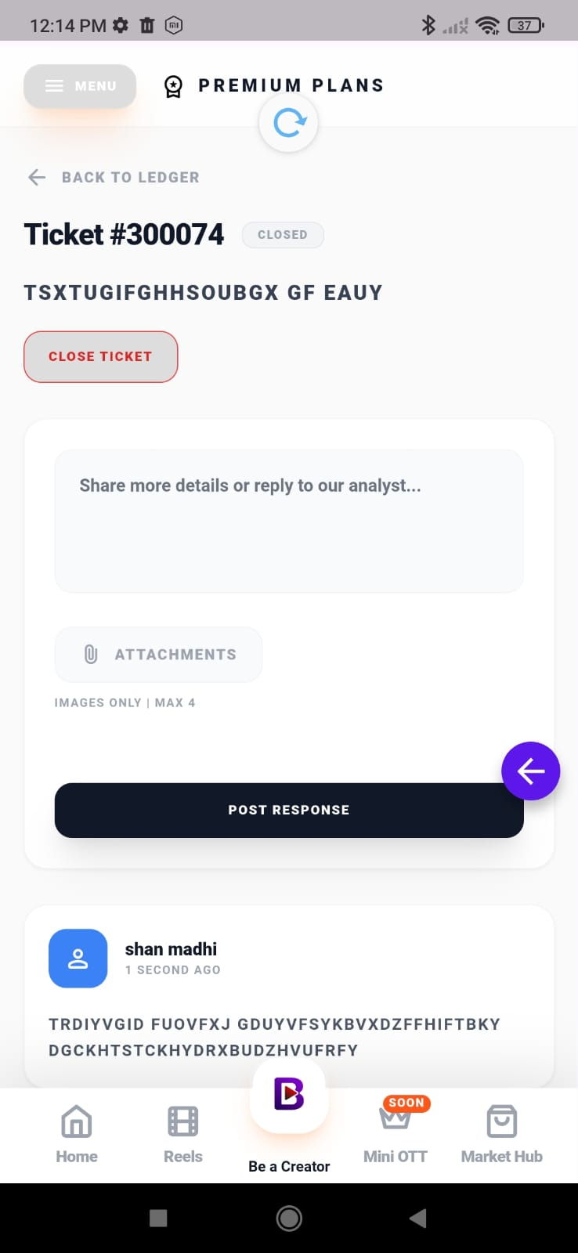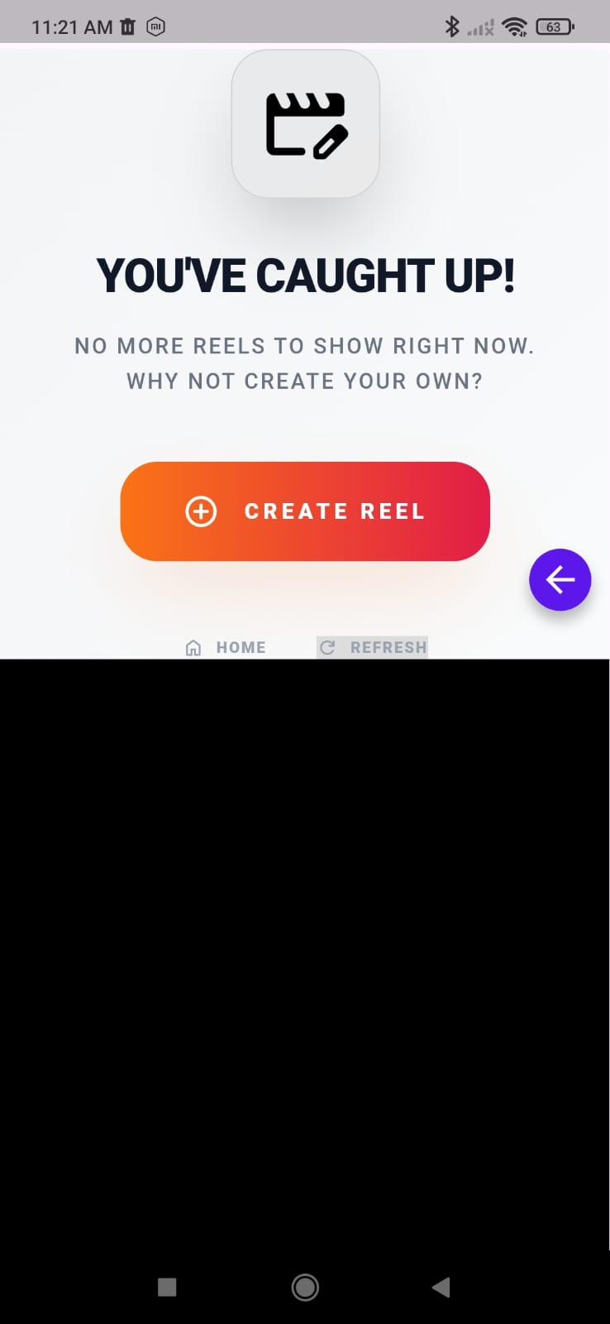

22. FINAL TESTING CONCLUSION
Binteo was manually tested across Vivo Y21e, Vivo Y200 and Redmi Note 8 Pro to evaluate functional behaviour, UI consistency, navigation, authentication, content management, reels, video playback and device compatibility.
The application demonstrated successful behaviour in several core flows, but multiple defects and inconsistencies were identified during cross-device testing.
The identified defects should be addressed and a complete regression test should be performed on all three devices, particularly focusing on authentication validation, theme handling, navigation, Support Desk, profile/creator features, video playback and Reels.
Testing Status: Defects Identified – Retesting Recommended
Tested By: P. Shanmathi
Application: Binteo
Testing Type: Manual Testing – Multi-Device Functional, UI, Compatibility & Regression Testing

